­­­­­

**USER MANUAL**

BY

**SFC CODE AVENGERS**

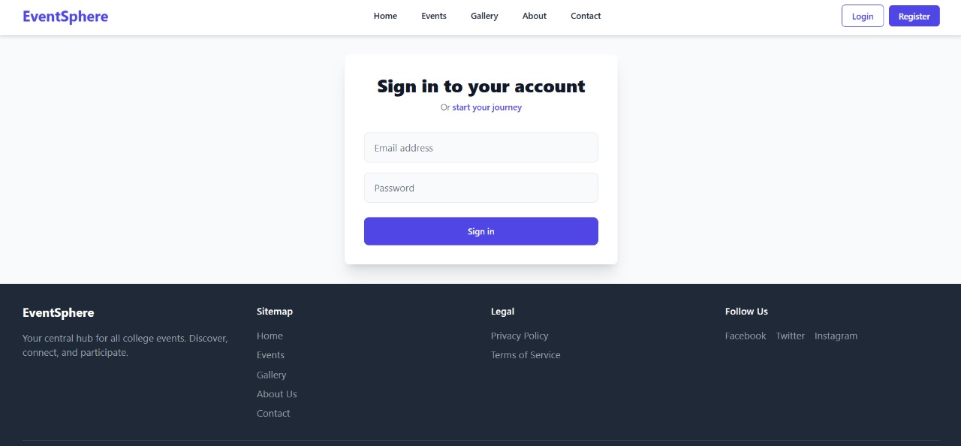

***Overview***: The **EventSphere** platform supports a multi-role login and signup system that allows users to access functionalities based on their role: **Participant**, **Organizer**, or **Admin**. Each role has a dedicated dashboard OR Panel, while also having the ability to explore the general event website.



**Signup & Sign-in Page**

* The login interface provides a centralized **Sign-in** form where users enter their **email address** and **password** to access their accounts.
* A **Register** (Signup) button is also provided, which leads users to the registration form, allowing them to create a new account with their appropriate role.
* The login interface provides a centralized Sign-in form where users enter their email address and password to access their accounts.
* A Register (Signup) button is also provided, which leads users to the registration form, allowing them to create a new account with their appropriate role.

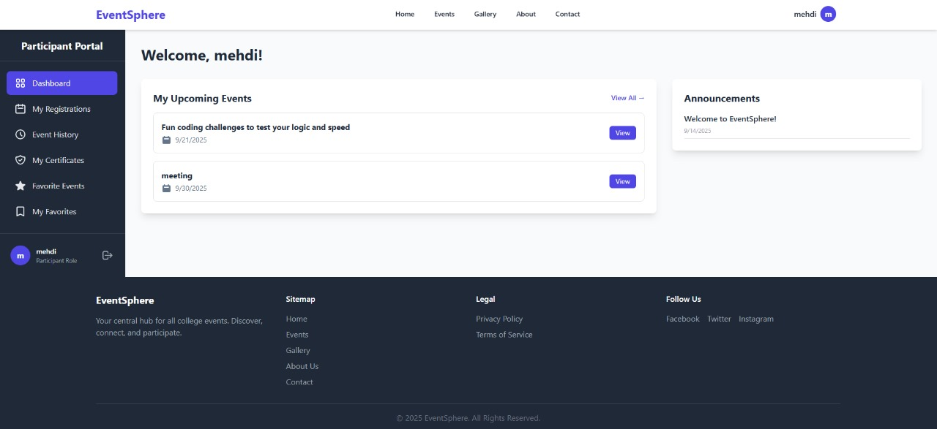

**Participant Dashboard**

* The login interface provides a centralized **Sign-in** form where users enter their **email address** and **password** to access their accounts.
* A **Register** (Signup) button is also provided, which leads users to the registration form, allowing them to create a new account with their appropriate role.

• After **signing in**, participants are directly redirected to their **Personal Dashboard**.

• From the dashboard, they have the option to **navigate to the Home page** using the **Home button** in the navigation bar.

• Inside the dashboard, participants can:

* View all available events
* View their **registered events**
* **Update** their profile information
* **Cancel participation** in events (if permitted by the event rules)

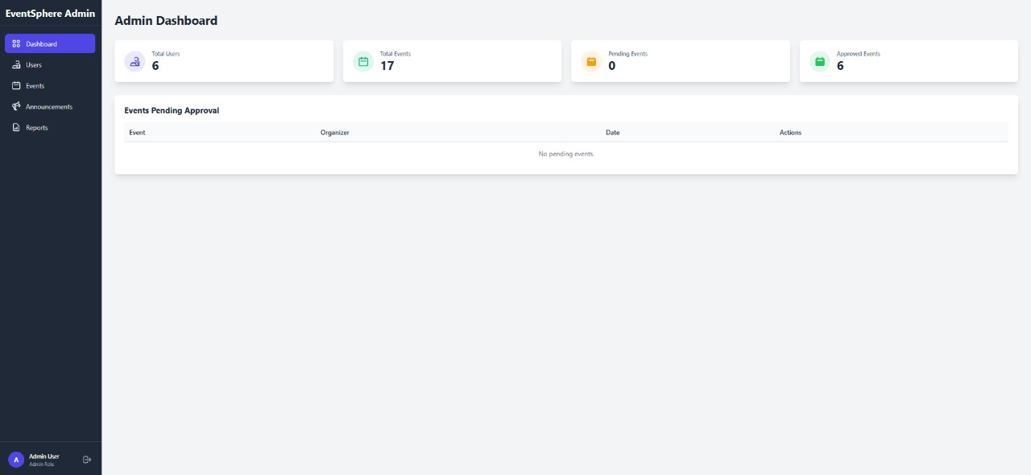

**Admin Dashboard**

* The login interface provides a centralized **Sign-in** form where users enter their **email address** and **password** to access their accounts.
* A **Register** (Signup) button is also provided, which leads users to the registration form, allowing them to create a new account with their appropriate role.

• Admins have the most privileged access.

• After logging in, they are redirected to the **Admin Dashboard**.

• Admin can:

* Manage users (participants and organizers)
* Approve or reject events
* View full activity logs
* Manage site-wide settings (like homepage content or gallery images)

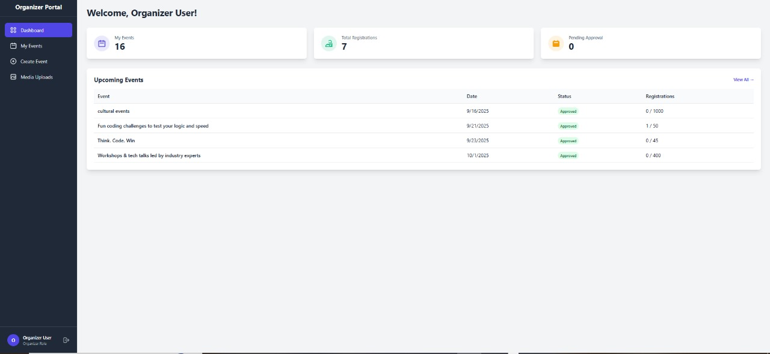`

**Organizer Dashboard**

* The login interface provides a centralized **Sign-in** form where users enter their **email address** and **password** to access their accounts.
* A **Register** (Signup) button is also provided, which leads users to the registration form, allowing them to create a new account with their appropriate role.

• Upon login, organizers are redirected to their **Organizer Panel**.

• They can also access the public website interface.

• Organizer capabilities include:

* Creating new events
* Managing event details
* Viewing participant lists
* Communicating with admins if required



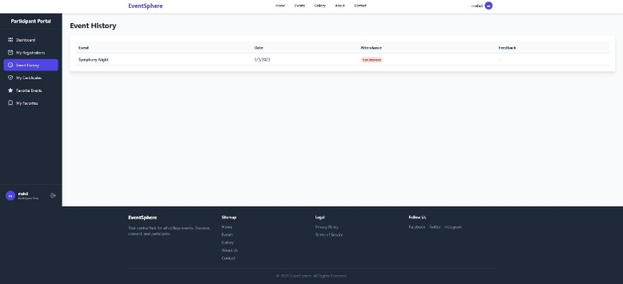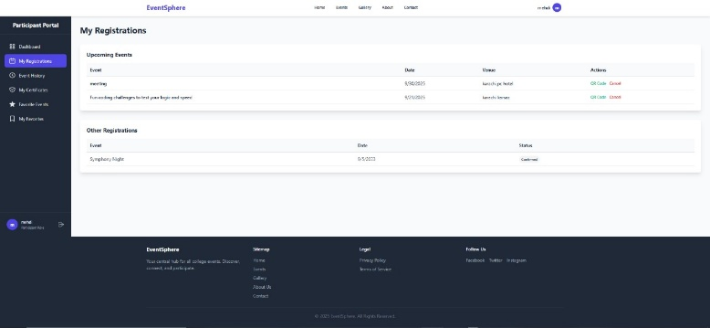

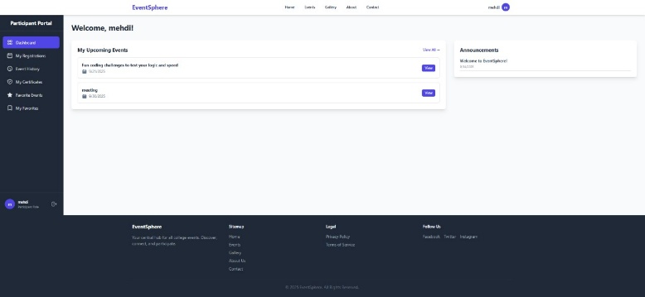

**Participant Dashboard**

#### 1. ****Dashboard (Home)****

This is the welcome page for the participant after login. It displays a personalized greeting along with a list of **upcoming events** the user has registered for. There's also an **"Announcements"** section to notify participants about important updates or new events added by organizers or admins.

#### 2. ****My Registrations****

This section lists all the events the participant has registered for. It is divided into:

* **Upcoming Events** – Events that are yet to happen, with details such as date, venue, and an option to cancel the registration if needed.
* **Other Registrations** – Past or canceled events for record-keeping.

#### 3. ****Event History****

This page shows a complete history of events the participant has attended. It includes:

* Event name
* Date of the event
* Attendance status (e.g., "Attended", "Missed")
* Option to provide **feedback** after attending the event

#### 4. ****My Profile****

In this section, participants can **view and update their personal information** like name, email, and password. It ensures that users maintain up-to-date records for better communication and identification.

#### 5. ****My Certificates****

Participants can access **event participation certificates** from this page. Certificates become downloadable only after attendance is confirmed by the event organizer or admin.

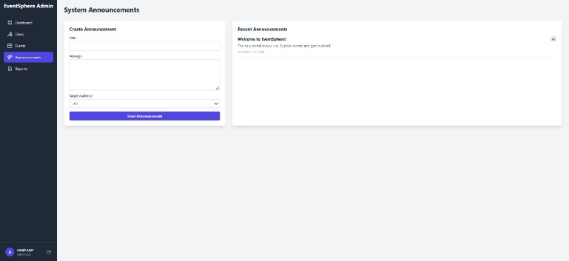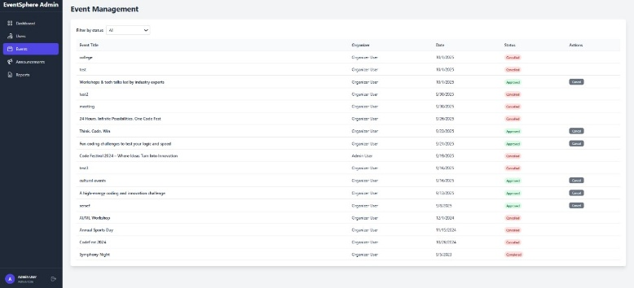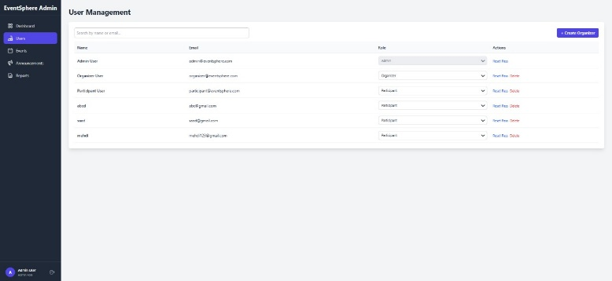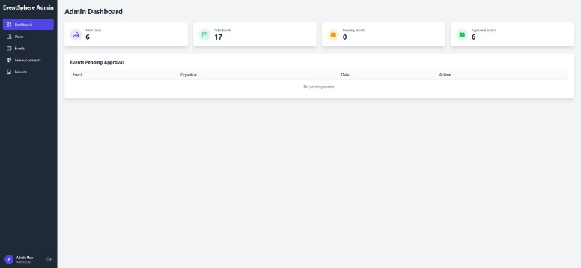

**Admin Dashboard**

#### ****Dashboard (Overview)****

The main dashboard provides a quick summary of:

* Total users
* Total organizers
* Total approved and pending events  
  Below the stats, there’s a table for **pending event approvals**, allowing the admin to review and approve or reject events submitted by organizers.

#### 2. ****User Management****



This section lists all registered users, including participants, organizers, and other admins. Admins can:

* **Search users**
* View user details (name, email, role)
* **Verify**, **Edit**, or **Delete** users  
  There’s also an option to manually **create a new user** if needed.

#### 3. ****Event Management****

Admins can view and manage all events created on the platform. Each event entry includes:

* Event title
* Organizer name
* Event date
* Current status (e.g., Approved, Rejected, Pending)  
  Admins can quickly take actions such as approving, rejecting, or editing event details.

#### 4. ****System Announcements****

Admins can **create and publish announcements** that are displayed to participants and organizers on their dashboards. The form includes a text area for content and role-based targeting (e.g., only participants or all users). On the right, recently published announcements are listed.

#### 5. ****Reports****

(Not shown in detail, but present in the sidebar) – This section likely provides downloadable or viewable reports related to event performance, user activity, and platform usage.

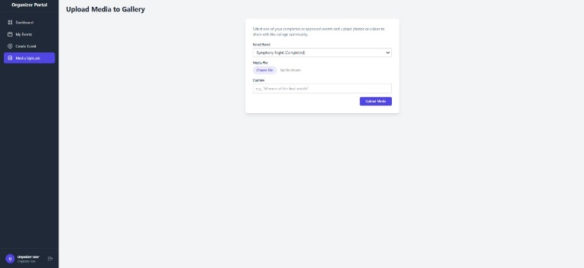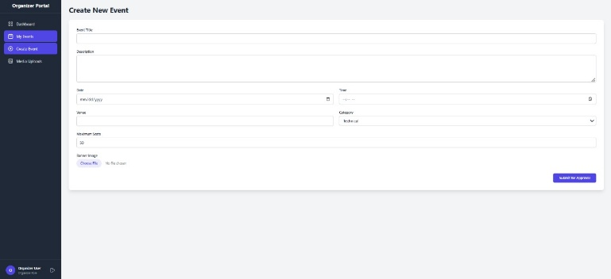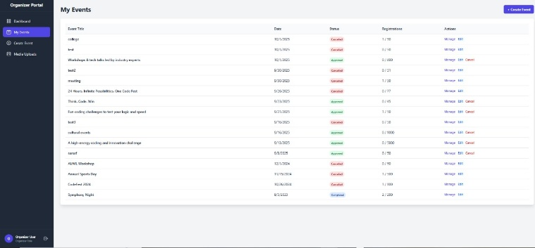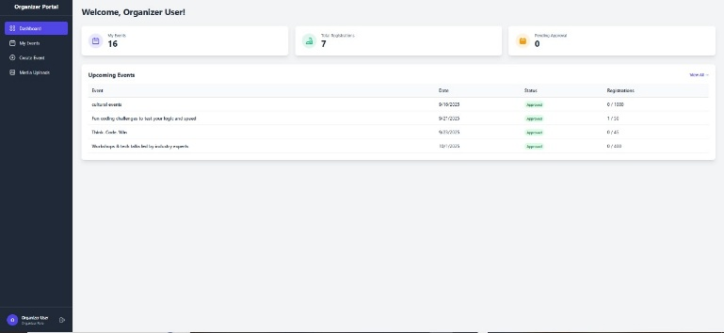



**Organizer Dashboard**

#### 1. ****Dashboard (Overview)****

The home page of the organizer panel shows a **summary of total events**, **registrations**, and any **pending events** awaiting approval. A table below lists **upcoming events** along with their current status (approved or pending), allowing organizers to keep track of their active lineup at a glance.

#### 2. ****My Events****

This section displays a complete list of all events created by the organizer. Each event includes:

* Title
* Date
* Status (Approved, Rejected, Pending)
* Number of **Registrations**
* Action buttons to **Edit**, **View**, or **Cancel** the event

Organizers can keep an eye on engagement and take appropriate actions in real-time.

#### 3. ****Create Event****

Organizers can create new events by filling in essential details such as:

* Event title
* Description
* Date and time
* Venue and contact info

Once submitted, events go to the admin for approval before being published on the platform.

#### 4. ****Upload to Gallery****

This feature allows organizers to upload images and media from their events to the **website gallery**. They can select the related event, give a title or caption, and submit the media, which enhances visibility and builds a visual history of campus activities.

THIS IS TEACHER PORTAL FEEDBACK PAGE WHERE TEACHER CAN UPDATE THE MISTAKES AND ISSUE REGARDING THIS WEBSITES.

THIS IS STUDENT PORTAL ACADEMIC PROGRESS PAGE WHERE THEY CAN WATCH THERE PROGRESS UPDATE.